Name: |  |  |  |  | 50  = %
 | Year 11 Essentials  Practical Application 4, 2015  Topic – Networks
Weighting: |  | 13% of the semester | Time allowed: | 60 minutes
A network consists of nodes, paths and regions. Nodes are connected by paths. In the Diagram 1 below there are two nodes connected by two paths. In Diagram 2 there are two nodes and 3 paths. In Diagram 3 there are two nodes and one node has a looped path.

Diagram 1 Diagram 2 Diagram 3

The order of nodes is related to the number of paths that meet at a node. In Diagram 4 the node labelled A is said to have an order of 3, the node labelled B is said to have an order of 4 and node labelled C is said to have an order of 1.

Diagram 4

1. (10 marks)
A traversable network can be defined as a network in which each node is visited and each path is travelled only once. You can test this if when you trace each path exactly once by beginning at a point and not lifting your pencil from the paper.

Consider the networks below. Show which of the networks below are traversable. Clearly mark the point where you start (S) and the point where you finish (F).

2. (4 marks)
Draw four traversable networks of your own, showing start, finish and direction of the journey.

- (16 marks: 8, 8)

  - The networks below are all traversable. Check this and clearly mark the point where you start (S), and the point where you finish (F).

  - On the diagrams mark each node with odd (O) or even (E).

Note that: An odd node is a node which has an odd number of paths going to it. An even node is a node which has an even number of paths going to it.

c. Then complete the following table using all of the networks above.

Network | Total Number  of Nodes | Number of  Even-Nodes | Number of  Odd-Nodes
1.
2.

4. (2 marks)

When is a network traversable?

5. (2 marks)
Below is a network that shows the roads and towns of a salesperson’s trip. The salesperson can leave home and go to every town and return home without going over any road twice. The salesperson lives in one of the following towns. Circle the correct answer.
(i) A
(ii) B
(iii) C
- D
- E

6. (2 marks)
The following network is not traversable. Add a path between two nodes to make it traversable.

Part 2: Drawing Networks
Here is a table showing the distances between towns

 | A | B | C
A | - | 3 | 2
B | 3 | - | 7
C | 2 | 7 | -

This can also be drawn as a network
Draw the towns (nodes) | Draw the roads (paths) | Write down the distances
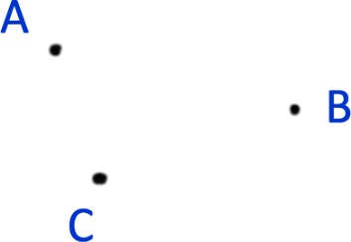 | 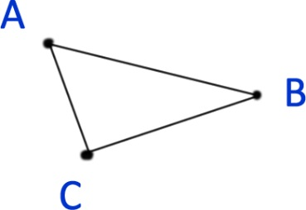 | 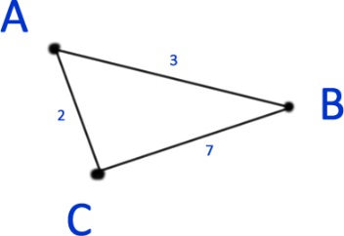

7. (7 Marks: 3, 4)

Use the tables to draw the appropriate networks
a)
 | G | H | I
G | - | 5 | -
H | 5 | - | 4
I | - | 4 | -

b)
 | A | B | C | D
A | - | 4 | 2 | 1
B | 4 | - | - | 7
C | 2 | - | - | -
D | 1 | 7 | - | -

8. (3 Marks)

Suppose you need to travel from Tacoma, WA (vertex T) to Yakima, WA (vertex Y). Looking at a map, it looks like driving through Auburn (A) then Mount Rainier (MR) might be shortest, but it’s not totally clear since that road is probably slower than taking the major highway through North Bend (NB). A graph with travel times in minutes is shown below. An alternate route through Eatonville (E) and Packwood (P) is also shown.
96
79
27
76
96
57
20
36
104
T
A
NB
MR
E
P
Y

9. (4 Marks)

Write down the length of the shortest path from S to F.

